

**NRCS National Highly Erodible Land Conservation (HELC) Tool**

**State Tool Administrator Guide**

**Tool Version – 1.0.2**

**January 2024**

**Table of Contents**

Overview 1

Purpose 1

Background 1

State Tool Administrator 2

User Requirements 2

System Requirements 2

HEL Frozen Soil Data 2

Food Security Act 2

State Tool Administrator Deployment Workflow 3

Create GeoPortal Account 3

GeoPortal Account 3

Grant CLU Access 3

Install Base Software 4

Install ArcGIS Pro 4

License ArcGIS Pro 4

Install the HELC Tool 5

Delete Existing Install 5

Download the HELC Tool 5

Unzip the HELC Tool 6

Create Determinations Directory 6

Configure ArcGIS Pro 7

Configure ArcGIS Pro General Options 7

Configure Portals in ArcGIS Pro 7

Customize State APRX Template(s) 8

Create State Template File 8

Set WGS 1984 UTM Coordinate System 9

(Optional) Add Data to the State Template 10

(Optional) Create More State Templates 10

Update Address CSV Tables 11

Deploy HELC Tools within the State 12

Deploy and Maintain Supporting Geodata 12

Repackage HELC Tool with State Customizations 12

Deploy the Custom HELC Tool Files 12

Provide Installation Instructions to Users 13

Train Users 13

Appendix A – Creating the HEL Frozen Soil Data Layer 14

States With Existing HEL Frozen Soils Data 14

States Without Frozen HEL Soils Data 14

Configuring the HEL Frozen Soil Data 16

Format the HEL Frozen Soil Data 17

Data Model 17

MUHELCL Values 18

MUWATHEL or MUWNDHEL Values 18

T, K, R Values 18

Distributing HEL Frozen Soil Data 18

Appendix B - Advanced Support Scenarios 19

Updating Determinations 19

Override a Result Based on a Previous Determination 19

Determination Changed Using the Same Project Folder 19

Determination Changed Using a New Project Folder 19

Appendix C – Troubleshooting 20

Issue Reporting 20

Known Issues 20

Appendix D – Customizing HELC Tool Letter Templates 21

Appendix E – NRCS of the Future HEL Team Development Notes 22

Tool Development Guidelines 22

Tool Products 22

Tool Administration and Distribution 23

Soil Data 23

Elevation Data 23

GIS Details 23

NRCS of the Future HEL Tool Development Team (2019) 24

References 24

# Overview

## Purpose

The Natural Resources Conservation Service (NRCS) makes Highly Erodible Land Determinations under Food Security Act's conservation provisions. This Administrator Guide provides instructions to State Tool Administrators to implement and deploy the HELC Tool in their state.

Note: This tool is not suitable for use on fields with extensive constructed practices that significantly alter the landscape and hydrography, such as terraces.

## Background

The 1985 Food Security Act, as amended, established the Highly Erodible Land (HEL) Conservation provisions as a condition of eligibility for USDA Program benefits. The NRCS follows guidance from the National Food Security Act Manual, Fifth Edition, which gives the conditions under which fields will be determined HEL or NHEL.

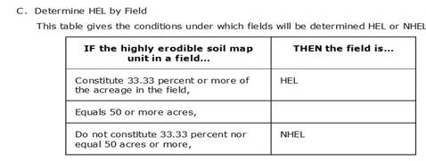

The Soil Erodibility Index (EI) for a soil map unit is determined by dividing the potential erodibility for the soil map unit by the soil loss tolerance (T) value established in the FOTG as of January 1, 1990 [7CFR Section 12.21]. A soil map unit with an EI of 8 or greater is considered to be highly erodible.

A soil map unit is listed as *potentially highly erodible* (PHEL) whenever a soil map unit contains a range of LS values which result in RKLS/T quotients both above and below 8. Potentially highly erodible soil map units (PHEL) are evaluated on a field-by-field basis as part of the determination process and assigned a highly erodible or non-highly erodible rating.

The December 7, 2018 update to the regulations at 7CFR12 and provides for the offsite evaluation of PHEL soil map units using offsite methods.

For a complete description of the HEL Soil Erodibility Index, refer to M_180_NFSAM_511. Calculation of the topographic factor (LS) is described in the USDA Agriculture Handbook No. 537.

## State Tool Administrator

The HELC Tool is designed to be customized and distributed at the State level by one or more staff members designated by the State Conservationist (e.g., Business Tools Specialist, GIS Specialist, Compliance Specialist, and/or Area staff or Subject Matter Expert positions). This guide refers to the designated staff member(s) as the State Tool Administrator. The State Tool Administrator is responsible for customizing and deploying the HELC Tool to their state, and training and supporting the HELC Tool within their state.

## User Requirements

HEL Conservation Job Approval Authority (JAA) - The HELC Tool is exclusively intended for making Food Security Act (FSAct) Highly Erodible Land Determinations. Use of the tool assumes knowledge of FSAct procedures and State designated JAA for making HEL Determinations.

GIS Skills – The HELC Tool requires use of ArcGIS Pro. Users require basic skills in ArcGIS Pro navigation, attributing, and map layout creation. Support from the State GIS Specialist and/or State Tool Administrator is required to ensure that users properly install and use the HELC Tool.

## System Requirements

This HELC Tool requires the following software and accounts.

1. ArcGIS Pro version 3.0.3 or higher (3.1.x recommended). A template created with ArcGIS Pro 2.9 is available in the installation, for users who do not have ArcGIS Pro version 3.x yet.
2. User account access to USDA GeoPortal.
3. A secure connection (in office, or VPN if out of office) to the USDA network is needed to download the latest CLU data for each project site, and possible NRCS Bare Earth elevation data if using the NRCS Bare Earth services, as well as to check out a Spatial Analyst extension if not already configured by a user.

## HEL Frozen Soil Data

The HELC Tool for ArcGIS Pro uses the same format for HEL Frozen Soil Data as the ArcMap HEL Tool used. Refer to Appendix A for guidance on creating an HEL Frozen Soil Data layer, as well as the Frozen Soil Data layer’s Data Model.

## Food Security Act

Resources related to the NRCS Highly Erodible Land Conservation provisions can be found in the Highly Erodible Land and Wetland Conservation section of the [NRCS Share Point](https://usdagcc.sharepoint.com/sites/nrcs/intranet/Shared%20Documents/Forms/AllItems.aspx?csf=1&web=1&e=8iI8IN&cid=f802a3e7%2D5f35%2D41e6%2Da69a%2D07cf693536d0&FolderCTID=0x01200048D1207AA08C8C48A67354B407FAE00C&viewid=641e088f%2D18b3%2D4e60%2D95ae%2D680136adee2d&id=%2Fsites%2Fnrcs%2Fintranet%2FShared%20Documents%2FHighly%5FErodible%5FLand%5Fand%5FWetland%5FConservation), the [Conservation Compliance and USDA Programs](https://www.nrcs.usda.gov/wps/portal/nrcs/detailfull/national/programs/farmbill/?cid=nrcseprd1542016) webpage, in the [eDirectives](https://directives.sc.egov.usda.gov/) under Manuals à Title 180, and in the [Code of Federal Regulations](https://www.ecfr.gov/).

# State Tool Administrator Deployment Workflow

The following outline shows the steps that a State Tool Administrator needs to perform to deploy the tool in their state. The remaining sections of this guide provide details for each step.

* Create GeoPortal Account
* Create and Distribute HEL Frozen Soil Data (see Appendix A)
* Install Base Software – ArcGIS Pro
* Install the HELC Tool
* Create State APRX Template(s)
* Update NRCS, FSA, NAD Address CSV files and import them to the tool
* Deploy HELC Tool within the State
* Train and Support HELC Tool Users within the State

# Create GeoPortal Account

State Tool Administrators will need to have an account on GeoPortal to access the CLU data with this tool. As a State Tool Administrator, please complete the following steps to configure your GeoPortal account, if you don’t already have one.

## GeoPortal Account

This section describes how to create a GeoPortal Account so that you can access the CLU layer in the HELC Tool. You do not need to complete this section if you already have a GeoPortal account.

* Open Chrome or Edge, or a new tab in one of those browsers.
* Navigate to <https://gis.sc.egov.usda.gov/portal/home>
* Click *Sign In* in the top-right corner of the screen to sign-in with your LincPass or Eauth.
* After signing-in, you are done with GeoPortal account setup. Your account on GeoPortal only needs to exist to access CLUs.



## Grant CLU Access

As a State Tool Administrator, you will also need to instruct users to have a GeoPortal account. This account creation is also covered in the user guide for this tool.

* Instruct an employee to sign-in to the [GeoPortal](https://gis.sc.egov.usda.gov/portal/home) home page.
* An account either exists or is automatically created for them on first sign-in.
* They now have access to download up to date CLUs within the HELC Tool.

# Install Base Software

All base software is available through Software Center. If there is any trouble with Software Center installs, you will need to contact CEC for assistance.

## Install ArcGIS Pro

The HELC Tool is built within ArcGIS Pro. ArcGIS Pro can be installed by users from *Software Center* and is also required by State Tool Administrators to configure the HELC Tool. As a large program, it is recommended to perform the install while connected to the USDA network via the best available network connection, typically the Service Center or duty station for an employee. It is recommended that users you support have the same version of ArcGIS Pro as you. The following versions are supported by the HELC Tool:

* **ArcGIS Pro 2.9.x** – Install ArcGIS Pro 2.9.32739 followed by the latest ArcGIS Pro Patch for 2.9

OR

* **ArcGIS Pro 3.0.x** – Install ArcGIS Pro 3.0.3 (v3.0.36057) followed by the latest ArcGIS Pro Patch for 3.0

OR

* **ArcGIS Pro 3.1.x** **(recommended)** – Install ArcGIS Pro 3.1.0 (v3.1.0.41833) followed by the latest ArcGIS Pro Patch for 3.1

## License ArcGIS Pro

USDA employees must configure *Concurrent Licensing* for ArcGIS Pro from the USDA license servers. Please refer to the *Licensing* section of the [***Getting Started with ArcGIS Pro***](https://usdagcc.sharepoint.com/sites/FPAC-NRCS-GIS/Training/Forms/AllItems.aspx?id=%2Fsites%2FFPAC%2DNRCS%2DGIS%2FTraining%2F1%20Getting%20Started%20with%20ArcGIS%20Pro%2Epdf&parent=%2Fsites%2FFPAC%2DNRCS%2DGIS%2FTraining) guide from FPAC-GEO for details on configuring licenses. The *Advanced* license option for ArcGIS Pro is required for the HELC tool. When instructing users to install and license ArcGIS Pro in your state, be sure to include licensing instructions appropriate to your state, either from the *Getting Started with ArcGIS Pro* guide or your state’s equivalent document. Note that Portals guidance in this document may supplement or exceed the Portals guidance from the *Getting Started with ArcGIS Pro* guide.

Note: ArcGIS Pro 3.1.x and later installations from Software Center automatically configure ArcGIS Pro licensing, although you may want to review the additional Extensions that you may need for other GIS work and to recommend to your users. Notes on selecting Extensions are included in the *Getting Started with ArcGIS Pro* guide referenced above. This tool does require the Spatial Analyst Extension, but it will automatically check out that extension if the user is on the USDA network.

# Install the HELC Tool

## Delete Existing Install

Old versions of the HELC Tool should be deleted prior to downloading a new version. This section is only needed if you have pre-existing versions of the HELC Tool, and previously run projects.

* Open *File Explorer* and navigate to *C:\GIS_Tools*, or to the other location your state has designated for tool installation.
  + (OPTIONAL) Go to the *…\SUPPORT\Templates* folder within the existing install and copy the *NRCS_Address.csv* file, the *FSA_Address.csv* file, and the *NAD_Address.csv* file. Paste the files elsewhere on your system to be retained for future reference.
  + At the installation location level (e.g., *C:\GIS_Tools*, or other folder you’ve designated for install) select and delete the *HEL* folder.
* Navigate to *C:\Determinations*, if it exists.
  + **Real Sites Run for Production**: Backup project folders to an external drive. Then delete the project folders from *C:\Determinations*. Any in-progress projects may need to be started over in the new version.
  + **Test Sites Run for Training**: Delete these project folders from *C:\Determinations*.

## Download the HELC Tool

The HELC Tool is available for download from the following repositories or links by State Tool Administrators, and not normal users. State Tool Administrators should use these locations to download the generic version of the HELC Tool prior to applying State-level customizations. After applying customizations, State Tool Administrators should repackage their custom version of the tool and deploy it within their state according to the state’s preferred distribution methods.

* HELC/WC SharePoint:  
  [National NRCS HELC/WC SharePoint – GIS Tools Folder](https://usdagcc.sharepoint.com/:f:/r/sites/nrcs/intranet/Shared%20Documents/Highly_Erodible_Land_and_Wetland_Conservation/GIS%20Tools?csf=1&web=1&e=jZ4Ram)
* GitHub:   
  <https://github.com/USDA-NRCS/HEL-Tools>

## Unzip the HELC Tool

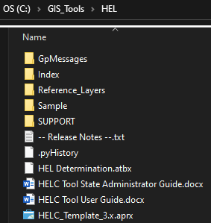The HELC Tool must be unzipped so that it resides in in a folder on the C: drive on the local computer. A suggested directory that you could create for this purpose would be “GIS_Tools” on the C: drive. If this directory does not exist, you can create it manually prior to unzipping.

After unzipping, the resulting installation path should be:  
**C:\<install folder>\HEL**   
It should appear similar to the screenshot to the right.

It is *not* recommended to place the HEL folder directly at the C: drive level to not conflict with the old ArcMap HEL Tool’s installation location.

In this example, the “GIS_Tools” folder is used as the install folder and will remain as the example install folder throughout this guide.

If you have additional directories between your desired install folder and the “HEL” folder after unzipping, drag and drop the “HEL” folder to be directly in the install folder of your choice (“GIS_Tools” in this example), and delete any excess folders.

Note: Slight variations of folders and files may exist, compared to the screenshots on this page.

## Create Determinations Directory

The **C:\Determinations** folder must be created if it doesn’t exist already.

* 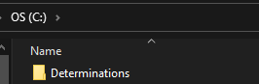Open *File Explorer* and navigate to the *C:* drive.
* Confirm that a *Determinations* folder exists.
* If it does not exist, create a new folder at the *C:* drive level and name it *Determinations*.

## Configure ArcGIS Pro

### Configure ArcGIS Pro General Options

For best results, the Project Recovery setting in ArcGIS Pro should be disabled. This prevents inadvertent file locks being applied to temporary datasets used for processing in the tools if a script fails or if ArcGIS Pro crashes. These steps are needed after any ArcGIS Pro install or patch.

* Open any ArcGIS Pro project (blank or existing).
* Click *Project* or *Settings*, then click *Options*, and then click *General*.
* Expand *Project Recovery* and disable the *Create a backup…* option.

### Configure Portals in ArcGIS Pro

The HELC Tool connects to the USDA GeoPortal to operate. Previous steps in the setup had administrators and employees create their accounts, but the steps in this section are specific to configuring access to GeoPortal from your local install of ArcGIS Pro. It is recommended that each user add GeoPortal in ArcGIS Pro after installing or updating ArcGIS Pro.

* Launch ArcGIS Pro (***Start 🡪 ArcGIS 🡪 ArcGIS Pro***). In the lower-left corner of the Pro window, click ***Settings***. From the list of settings, click ***Portals***.  
  Note: If you are in an active project, click the ***Project*** tab to access the ***Portals*** menu.
* A list of portals will be displayed. It will contain ArcGIS Online ([www.arcgis.com](http://www.arcgis.com)) by default, and any portals you’ve previously added. For first time users, only ArcGIS Online will be visible.

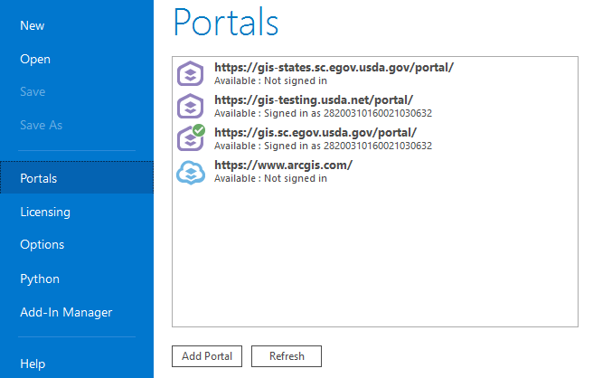

* If the following portal is missing from your list, click ***Add Portal***, type its URL in the box, and then click ***OK***.

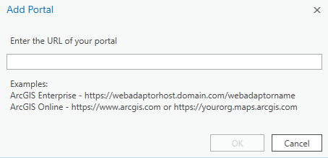

<https://gis.sc.egov.usda.gov/portal>

# Customize State APRX Template(s)

State Tool Administrators must create one or more State Templates prior to deploying the tool in their state. Typically, it is also a best practice to create or update State Templates whenever a new version of the tools is released.

## Create State Template File

A State Tool Administrator should create at least one template per UTM Zone in their state. An administrator may create additional templates to accommodate staffing structure and/or geodata deployment in their state, as needed.

* 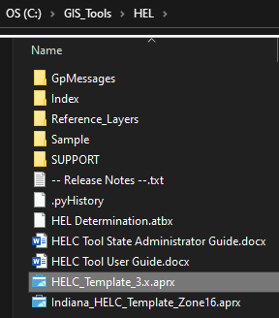Navigate to **C:\<install_folder>\HEL**and open a template APRX file. Be sure to select a template that is compatible with the version of ArcGIS Pro in use in your state, as indicated by the version number in the template file name.
* After the template opens, click *Project à Save Project As…*
* Navigate to:  
  **C:\<install_folder>\HEL**
* Give the template an appropriate name for its geography. You may also want to include the UTM zone in the name, if necessary.  
  Example: *Indiana_HELC_Template_Zone16*
* Click Save.

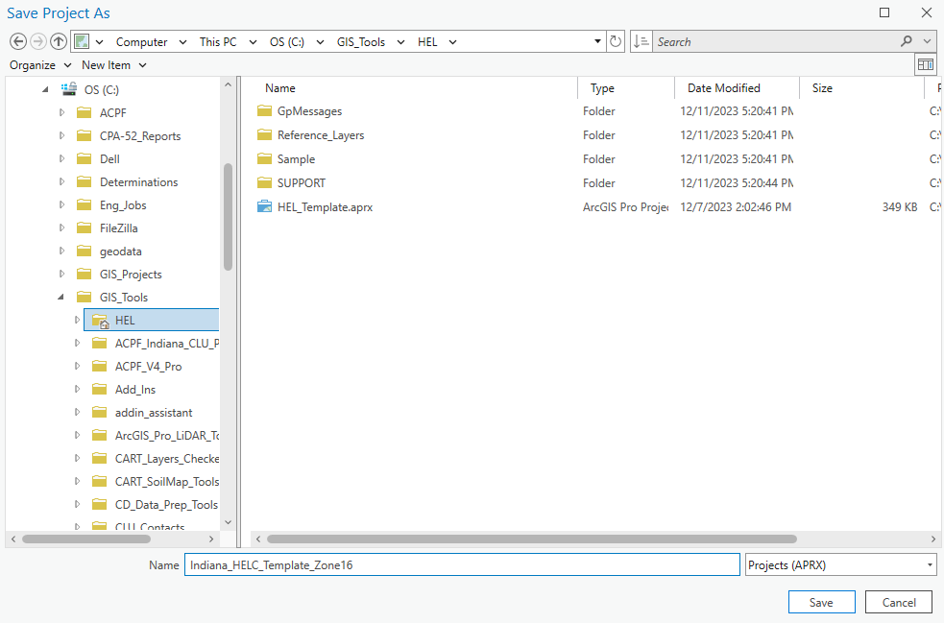

## Set WGS 1984 UTM Coordinate System

After creating the template file, a UTM Coordinate System must be assigned to the map. A WGS 1984 based UTM coordinate system is required by the tool to best align all data generated in the tool with the NAIP basemap available from GeoPortal.

* Open the *HEL_Determination* map within the project, if not already open.
* In the *Contents* pane, right-click the *HEL Determination* header name and then click *Properties*.
* Click the *Coordinate Systems* tab on the left side.
* In the *XY Coordinate Systems Available* box do the following:
  + Click *Projected Coordinate System à*
  + *UTM à*
  + *WGS 1984 à*
  + *Northern Hemisphere à*
  + *WGS 1984 UTM Zone #N*  
    Note:Replace “#” with the UTM zone number appropriate to your state or region and the file name you created in the previous step. Refer to this map [link](https://gis.sc.egov.usda.gov/portal/home/webmap/viewer.html?webmap=e5950ed38ac24f71bae6f06f1dc00284) for assistance in selecting zones when creating your State Templates.

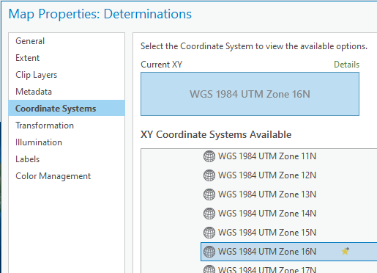

* Click OK to close the Map Properties window.
* Click Project 🡪 Save to save the project.

## (Optional) Add Data to the State Template

The State Tool Administrator can also add data layers to the State Template being created. State Tool Administrators should take care that users will have access to the same data layer sources when they access the templates.

* Use *Add Data* to add local or state layers needed in your state such as Frozen Soil Data, local LiDAR-based Digital Elevation Models (DEMs), current and/or historic imagery, transportation, hydrography, field data collection web services, etc…).   
  Note: The following layers are already included within default templateor will be generated by the HELC Tool workflow and do **not** need to be added again:
  + CLU – Nationwide Common Land Units map service
  + GeoPortal Imagery Basemaps – World Imagery is on by default. Alternate imagery basemaps are available from the Basemap button in ArcGIS Pro while you are signed-in to GeoPortal.
* (Optional) If coverage in your template’s area is available, use *Add Data* to add one of the NRCS Bare Earth Coverage services to the map, appropriate to your template’s area. Pre-made LYRX files for these services are available in **C:\<install folder>\HEL\Reference _Layers**. These layers can be used by users to determine if a bare earth service has coverage in for their county or site.

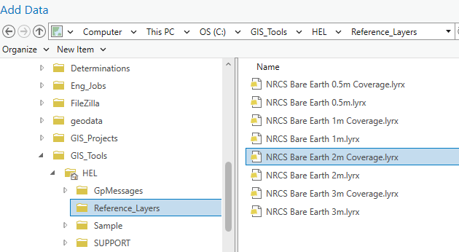

* Click Project 🡪 Save to save the project.

## (Optional) Create More State Templates

After finishing a template, repeat the template creation steps as necessary to create additional State Templates for each UTM Zone in your state, with optional reference data layers for the respective templates, as needed.

# Update Address CSV Tables

State Tool Administrators must update and import the NRCS and FSA Address tables prior to distributing the HELC Tool in their state. These CSV files contain the address information for the NRCS and FSA Service Centers, respectively, which are used as return addresses on the determination letters. State Tool Administrators should update the CSV files when first implementing the tools, or when directed in new release updates. You may be able to copy and paste contents from existing worksheets or CSV files used in previous versions of the tool but note any column changes and compensate accordingly. Do not try to set column or field types in the CSV files. The same files from the NRCS WC Tool can be used in this tool.  
***NOTE: DO NOT REORDER THE COLUMNS OR CHANGE THE HEADINGS IN ANY CSV!***

* Navigate to **C:\<install_folder>\HEL\SUPPORT\Templates**and open the *NRCS_Address.csv* file.
* Populate the ***NRCS_Offices*** tab.
  + Add one row per NRCS Service Center. Use the first row as an example of what to enter.
  + Delete the example row when finished.
* Save and close the *NRCS_Address.csv* file.
* Open the *FSA_Address.csv* file and repeat the above process to enter FSA Service Center info on the ***FSA_Offices*** tab. Use the first row as an example of what to enter.



* + List every FSA office by city in Column A and then complete its address information.
  + List the county the FSA office covers in column H.
  + If an FSA office covers multiple counties, list the office twice, duplicating its information in all columns except Column H, where you should distinguish the counties on each row.
  + Delete the example row when finished.
* Save and close the *FSA_Address.csv* file.
* (Optional) Open and review the *NAD_Address.csv* file in the same directory.
  + Make corrections to the content as needed.
  + Close the *NAD_Address.csv* file. Save only if you had to make changes.
* Open a State Template for the HELC Tool and open the Catalog pane.
* Expand *Toolboxes*, expand the *HEL Determination* toolbox. Expand section *C. Utilities*.
* Run the *Import Office Address Tables* tool. Close Pro when finished.

The updated versions of the NRCS, FSA, and NAD Address CSV files that you modified *should be included in the distribution of the HELC Tool for your state*. If done correctly, users will receive your updated address files to use as a starting point for rapid local updates, as needed.

In some cases, users may need to customize NRCS, FSA, or NAD addresses. In such cases, the State Tool Administrator(s) can refer them to Appendix E in the user guide or can assist users directly.

# Deploy HELC Tools within the State

After completing state level customizations to the HELC Tool, State Tool Administrators should package together the files they’ve updated and provide the state customized version of the HELC Tool to employees with their state. States have full discretion to carry out this process as appropriate to their staffing and data structure. The following sections describe some ways this might be managed.

## Deploy and Maintain Supporting Geodata

If the State Template customized for your version of the HELC Tool contains unique geodata for your state or parts of your state, please make sure that you provide your employees in the state with the necessary geodata to correspond to the provided templates. This should be done prior to providing them with the state customized version of the HELC Tool with the State Templates, or any time you make changes to your geodata structure that would impact the tools.

## Repackage HELC Tool with State Customizations

After creating State Templates and updating and importing addresses, along with any other additional customizations, be sure to repackage an updated and custom version of the HELC Tool for your state to be deployed to your employees. It is recommended to create a zip file of your HELC Tools folder which will include all your customizations by default:

* Close ArcGIS Pro, ArcMap, Excel, and Word if open. Close any application that may be accessing any file within the *HEL* folder.
* Create a new zip file on your computer. Do NOT create the zip file within the *HEL* directory.
* Drag and drop the *HEL* folder from the install directory on your computer into your new zip file so that all contents, including your custom contents, are copied into the zip.
* Save and close the new zip file.

## Deploy the Custom HELC Tool Files

After creating your state’s custom HELC Tool zip file for deployment, State Tool Administrators need to deploy the zip file to employees who will use the tool. They also need to notify the employees of the zip file’s availability and how to obtain it. There is no set way to do this, but the following suggestions are provided. Use the method that works best for your state, which may or may not include these options.

* Post the zip file on an NRCS State SharePoint Site for download by users.
* Post the zip file on GIS States in a User Group managed by your state for HELC Tool Users.
* Deploy the zip file to a shared drive, or all office shared drives, in your state.
  + Users can copy, paste, and extract the zip file from this location  
    OR
  + Provide the users with an extraction batch script that runs from USDA\Work to extract the files to a specific local directory.

## Provide Installation Instructions to Users

The National HELC Tool User Guides in the install folder is available to users, as is, for baseline documentation. This guide also contains instructions to install ArcGIS Pro, set up a GeoPortal account, and configure ArcGIS Pro. The national User Guide generally refers to *obtaining a custom version of the HELC Tool for your state from your State Tool Administrator*, where appropriate, so that users are not downloading the default tool from national that does not contain a state’s customizations.

Word document versions of the national guides are available in the install folder for use in your state, and you can add content to them to deploy your modified versions. However, it is recommended not to remove nationally created content from these guides and to only add further content or context, as needed. Some examples of items that may be useful to update for your state are where to find and download the state customized version of the HELC Tool or how to complete associated documentation procedures for a determination in your state.

If you do create customized user guides for the employees in your state, it is at your discretion for how to deploy those guides in your state.

## Train Users

State Tool Administrators will be the primary trainers for employees in their state. The HELC Tool is deployed in a Production version. This version can be used for training because no data uploads take place from the HELC tool to a legacy database. To use this version for training, use it as normal with a trainee, except you can delete the project folders after completing training walkthroughs.

Note: This tool shares its folder structure with the Wetlands Tool for ArcGIS Pro, so be careful not to train on sites that are used for in-work wetland determinations by the trainee.

The following suggestions are made to conduct a training with the tool.

* Follow this user guide to create a custom version of the tool for your state.
* Be sure to have yourself and all trainees sign-in GeoPortal so that they have an account there.
* Provide trainees with your state’s custom version of the HELC Tool to conduct the training.
* When guiding users through a scenario, you have two options for training data:
  + Conduct work on real requests and/or have students conduct work on individual requests. This has the best chance for you to find matching CLU tract numbers from the live CLU data service.
  + Conduct work on a single training scenario (check shortly before training to get the most up to date tract number for the site).
* Delete the training project folders from *C:\Determinations* after completing training.
  + Be sure that the training sites do not share active work with a wetland determination on the trainees’ computers, so that an active wetland determination project is not deleted.

# Appendix A – Creating the HEL Frozen Soil Data Layer

An HEL Frozen Soil Data layer represents the Soil Survey Area map unit boundaries and corresponding HEL factor values from the local Field Office Technical Guide (FOTG) as of January 1, 1990 (7 CFR 610.14). Carefully evaluate potential sources of data to determine if they are consistent with the January 1, 1990 “frozen” soil lists and associated linework. The State Soil Scientist is responsible for the development of this product.

Some initial soil surveys were still in progress or had not been started as of January 1, 1990. For these soil survey areas, the instructions below describe how to create a Frozen HEL Soil Data layer using the best available soil survey map unit boundaries and the amended or new HEL soil map unit lists. See the National Food Security Act Manual, Part 511.3  
(<https://directives.sc.egov.usda.gov/RollupViewer.aspx?hid=29362>).

## States With Existing HEL Frozen Soils Data

Review the Data Model later in this Appendix and fit your data to it.

## States Without Frozen HEL Soils Data

Determine if any digital survey was available or the closest to what was available as of January 1, 1990 and attribute or update that data for use with the tool. Any modification of existing boundaries or creating new features should meet the SSURGO data integrity standards including:

* Polygon (map units) will have no overlaps or gaps.
* Polygons intersecting the border of a project area shall be closed along the border.
* All polygons will be attributed.

Below are some options to obtain existing historical digital data. One or more of these options may be suitable for any given survey area within your state.

* Work with your State Soil Scientist to download the oldest SSURGO version in the Data Warehouse through the staging server and update it for use.

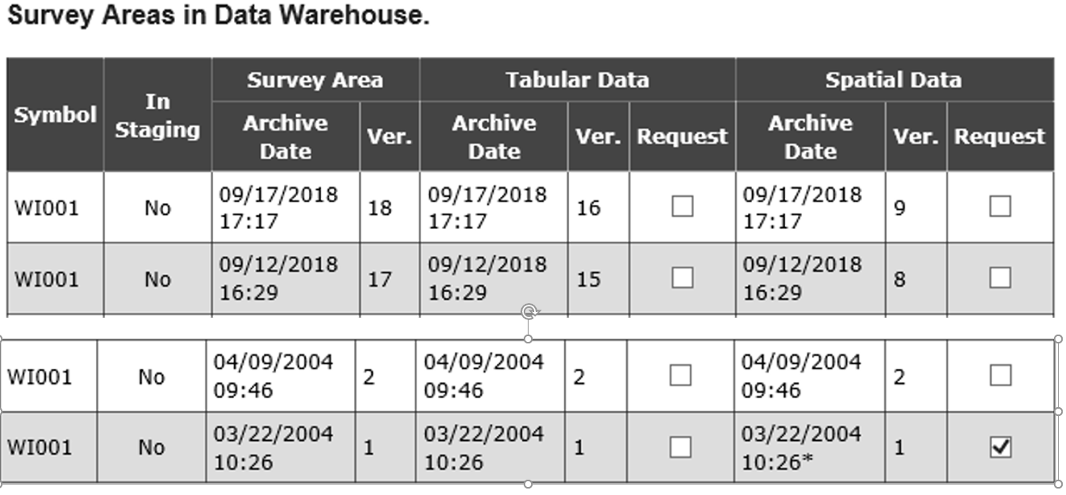

* Obtain preliminary SSURGO_V1 digitized data and review/update it for use with HEL.
  + Some Version 1 soil surveys are available for download from the site linked below. These datasets were assembled using the earliest and most complete spatial version of a Soil Survey Area (SSA). The majority of the SSAs were downloaded from the staging server (Soil Data Warehouse), however about 35% of the SSAs were digitized before the inception of the staging server. The Digitizing Unit has assessed each SSA (pre- and post-staging server) to post the earliest and most complete version of each SSA here.

\\aiomokcc6na102\smb04\Soil_Plant_Science_Division\NSSC\SSURGO_V1\Final_FGDB

Three different datasets are available at the above site. The order of preference for working with existing formats is zipped shapefile, followed by zipped coverage folder, followed by an unzipped coverage folder.

Note: Some surveys obtained at the above site may already contain update mapping in whole or in part and may not be consistent with the January 1, 1990 “frozen” soil lists and may require further editing.

* If you cannot find a digital soil survey that is consistent a survey used as of January 1, 1990, from the above sources, then you may be able to create a digital Frozen HEL Soil Data product from locally archived data in your state. If such data exists, use the earliest digital data available after final correlation was completed.
* Modern digital product linework can be adjusted back (via editing) to match the version in place as of January 1, 1990. The modern product is only effective for this purpose if it very closely parallels the survey as it existed as of January 1, 1990. Wholesale map unit changes are better pursued as a complete digitizing project from the historical map sheet scans.
* If you cannot find any digital data but the survey area was mapped in print, you could pursue a potential digitizing and attributing project project of the historical map sheet scans, after which you could add the attributes from the “frozen” lists to the data.

## Configuring the HEL Frozen Soil Data

No matter how you obtain frozen digital data, it needs to be setup to utilize the HEL Tool data model.

* 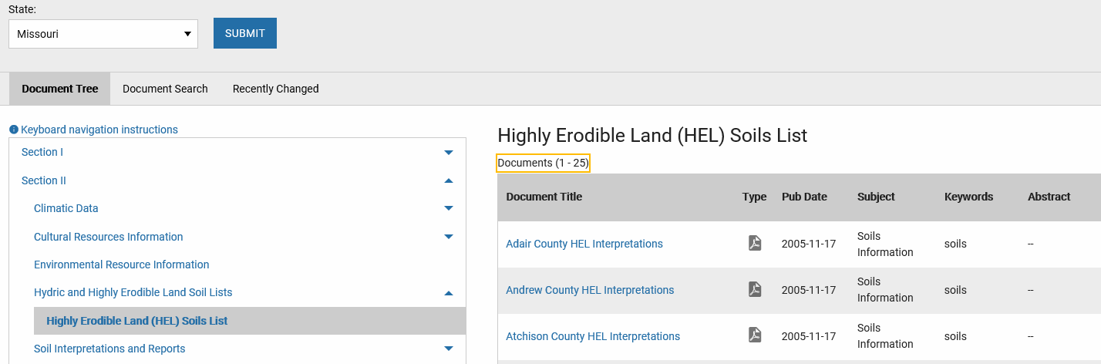Download or create a version of the Highly Erodible Soils (Frozen) list from Section 2 for your state on the eFOTG (<https://efotg.sc.egov.usda.gov/#/>).
* Convert the list to a table that is usable in GIS (e.g.; CSV format).
* Create a new file geodatabase named. Use the naming convention in the *Format the HEL Frozen Soil Data* section, below.
* Import your existing Soil Survey Area HEL shapefiles or feature classes into the file geodatabase. Use the naming convention in the *Format the HEL Frozen Soil Data* section, below.
* Adjust the field names of the feature classes created in your file geodatabase to adhere to HEL Frozen Soils schema for the tool. Rename fields as necessary using the Catalog 🡪 Data Design 🡪 Fields; or add and calculate fields to match the requirements of the *Data Model* section, below. The T, K, and R attribute values may be valid, or may be set to a default value of 0 for NHEL and HEL map units. PHEL map units require actual frozen attribute values for T, K, and R.
* Modify the digital frozen list you created to match the field names for needed for the HEL Frozen Data layer (see the Data Model earlier in this guide). The modified list must contain the MUSYM and MUHELCL fields. The MUHELCL field must be populated with the relevant Wind or Water HEL rating, as applicable to your survey area(s). You can also include MUNAME, C, or I fields, but the tool does not particularly use those fields.
* Evaluate the soil survey linework to determine if differences exist between the version in place as of January 1, 1990, from the copy you were able to obtain or digitize. If linework has not changed, a crosswalk legend between the digital product and the “frozen” soil list can be created. If linework has changed, values from the “frozen” soil list may need to be assigned to each MUSYM on a case-by-case basis.
* Use the downloaded list to update the attributes of the required T, K, R, MUWATHEL, MUWNDHEL, and MUHELCL attribute fields in the digitized survey areas. Optionally, you may be able to join the frozen list table to the data set you are authoring through the MUSYM field of each table, or a combination of the AREASYMBOL and MUSYM field.

Ideally, you could create a statewide HEL Frozen Soil Data layer. However, some states may need to create county or regional layers first, depending on geography or other considerations. The tool can be initially deployed for a small area until additional coverage areas are completed.

## Format the HEL Frozen Soil Data

After creating your digital dataset to represent Frozen HEL Soil Data as it corresponds to the January 1, 1990, survey, you should make sure it is formatted for use with the HEL Tool. The HEL Frozen Soil Data can be stored as a File Geodatabase (FGDB) Feature Class or as a shapefile. Data can be aggregated as a single layer or deployed by county or Soil Survey Area (SSA), or deployed by other geographic extents as needed for your state.

The recommended naming conventions are –

* File Geodatabase: HEL_frozen_<ST>.gdb
* Feature Class or Shapefile: HEL_Frozen_a_<STSSAID> or HEL_Frozen_a_<STNNN>

Where –

* <ST> = State postal abbreviation (e.g.; IN for Indiana)
* <STSSAID> = Combined state and soil survey area identifier (e.g.; WI602 for Milwaukee and Waukesha Counties , Wisconsin combined soil survey)
* <STNNN> = Combined state abbreviation and county FIPS code (e.g.; IN001 for Adams County, Indiana soil survey)

## Data Model

HEL Frozen Soil Data must follow the below attribute schema. Please note that field names may be case sensitive, so best practice would be to match the case of the Field Names in the below chart.

|  |  |  |  |  |
| --- | --- | --- | --- | --- |
| Field Name: | Data Type: | Length/ Precision | Values | Value Description: |
| AREASYMBOL | String | 20 |  | Soil Survey Area symbol |
| SPATIALVER | Long Integer | 9 |  | Version of the Soil Survey Dataset used |
| MUSYM | String | 8 |  | Original Frozen Map Unit Symbol |
| MUNAME (optional) | String | 254 |  | Map Unit Name |
| MUHELCL | String | 4 | HEL; NHEL; PHEL; NA | HEL classification for map unit |
| MUWATHEL (optional) | String | 4 | HEL; NHEL; PHEL; NA | Water Erosion HEL class for map unit |
| MUWNDHEL (optional) | String | 4 | HEL; NHEL; PHEL; NA | Wind erosion HEL class for map unit |
| T | Short | 7 | 1 to 5. Will not allow NULL. Default to 0. | Soil Erosion Tolerance value. (Required for PHEL mapunits only.) |
| K | float | 9 | 0.64; 0.55; 0.49; 0.43; 0.37; 0.32; 0.28; 0.24: 0.20; 0.17; 0.15; 0.10; 0.02; 0.05. Will not allow NULL. Default to 0. | Soil erodibility factor corresponds to the Kw value. (Required for PHEL mapunits only.) |
| R | Short | 7 | 10-700 in increments of 5. Will not allow NULL. Default to 0 | Rainfall erosivity factor based on rainfall intensity and amount. (Required for PHEL mapunits only.) |

## MUHELCL Values

The tool requires the [MUHELCL] field to be populated for each [MUSYM]. **Use “NA” if no values are assigned (Ex. water, quarry, mud, etc.).** The tool excludes “NA” values from the field calculations.

## MUWATHEL or MUWNDHEL Values

If your state only uses WATER erosion values for map units, populate the [MUHELCL] field with the water erosion HEL rating for each map unit. If your state only uses WIND erosion values for map units, populate the [MUHELCL] field with the wind erosion HEL rating for each map unit. States, counties, or Soil Survey Areas (SSA) that have BOTH wind and water values should ***assign the most restrictive HEL rating to the [MUHELCL] field for each map unit****.*

|  |  |  |
| --- | --- | --- |
| Wind HEL | Water HEL | MUHELCL |
| HEL | HEL, PHEL or NHEL | HEL |
| NHEL | HEL | HEL |
| NHEL | PHEL | PHEL (needs T, K, R values) |
| NHEL | NHEL | NHEL |

In the example below, the MUHELCL field for MUSYM 221 should be PHEL and the MUHELCL value for MUSYM 225 should HEL.

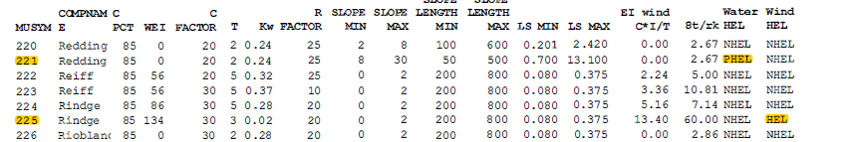

## T, K, R Values

T, K, and R attribute values are derived from FOTG section II frozen soil lists. T, K, and R attribute values are required for map units that have the PHEL MUHELCL designation in your data. For HEL and NHEL map units, the T, K, and R attributes may be set to zero for this tool, as the data is not used by the tool. Alternately, if the T, K, and R attributes are populated for HEL and NHEL map units in your data, that won’t break the tool.

## Distributing HEL Frozen Soil Data

The HEL Frozen Soil Data files needed to support the tool do not have to, and likely should not, reside in the installation folder for the HEL tool and should be maintained separately, such as somewhere in the geodata folder as you deem appropriate for your state. Although it is not mandatory, it is recommended for optimal performance to provide guidance for your users to download a copy of the HEL Frozen Soil Data files from your distribution point (e.g.; *F:\geodata\soils*) to their local computer (e.g.; *C:\geodata\soils*). You should design your template projects for this tool (see the template creation instructions later in the guide) to reference the HEL Frozen Soil Data from the same data source as your users will have when they receive your template(s) and use the tool.

# Appendix B - Advanced Support Scenarios

This appendix describes scenarios for modifying determination data. State Tool Administrators should refer to this section by scenario when answering questions or troubleshooting data maintenance.

## Updating Determinations

This section describes the various ways to update a determination and the considerations for each update scenario.

### Override a Result Based on a Previous Determination

In this scenario, a user needs to manually override an HEL or NHEL designation that was generated by the tool, usually due to a current field in the CLU being part of a recent split or merge by FSA and the client to change a single field into multiple fields or vice versa. Policy dictates particular HEL or NHEL labels may need to be set or retained depending on the scenario, regardless of the analysis of the new field extent. To do this, a user would edit the Field Determination layer to change the value in the “HEL_YES” field to HEL or NHEL as needed. To do this:

* Switch to the Edit tab in ArcGIS Pro
* Click the Attributes button
* Use the Select tool to select the field to change
* In the Attributes window, find the *HEL_YES* entry for the selected field
* For the *HEL_YES* value type in “HEL” or “NHEL”, as needed, and press Enter on your keyboard
* On the Edit tab/ribbon, click *Save* to save your edits
* Complete the rest of the normal workflow to create the Map, Form, Letter, and Report

### Determination Changed Using the Same Project Folder

In this scenario, the determination must be rerun for some reason, possibly due to noticing a mistake before issuing, and the determination project folder is on the current computer for the user. To correct the determination, simply open the APRX file saved in the project folder and run through the process again, or skip to a particular step in the process, make the needed correction, and move forward from that point.

### Determination Changed Using a New Project Folder

In this scenario, a different user needs to issue a new determination. The new user does not need access to the previous determination project folder and should always use the latest CLU data to do a new determination. This scenario might be typical if a new determination is requested due to a split or merge of fields on the Tract in question. The previous documents can be obtained from case files or the Document Management System (DMS) to determine if any manual label retention is required by policy. However, to generate a new determination with the tool, the new user can start the process from scratch to start a new determination using the most current CLU later. If an override label is needed after new results are generated, see the *Override a Result Based on Previous Determination* section, above.

# Appendix C – Troubleshooting

## Issue Reporting

Review existing issues and report new issues on GitHub at:

[https://github.com/USDA-NRCS/Wetland-Tools---ArcGIS-Pro/issues](https://github.com/USDA-NRCS/HEL-Tools/issues)

Note: You will need to create a GitHub account to report issues. Review open issues to see if the error or problem was already reported by a different user. Update or add further information to existing issues or re-open closed issues, if needed.

When you report or create a new issue, please provide a description, screenshots, and/or logs (if relevant). Please include your USDA e-mail address in either your issue description or your GitHub profile so that developers can contact you.

Note: Text logs for any given project can be found at *C:\Determinations\<project_folder>\<project_name>.txt*.

Sometimes developers can resolve an issue that your report without directly contacting you. If an issue can be resolved without further contact, comments may be added directly to the issue posts on GitHub and you can always check there for the latest changes. If you have disabled e-mail notifications for issue updates on GitHub, you may not see any communication that an issue was acknowledged or resolved and directly reviewing your issues may be the only way that you see that it is being reviewed or has been addressed.

Note: Not all resolved issues will be immediately deployed in the current release and an aggregation of fixes may be gathered before a new release is issued.

## Known Issues

Refer to *Appendix F – Troubleshooting* in the HELC Tool User Guide for a list of known issues.

# Appendix D – Customizing HELC Tool Letter Templates

Customizing the default/template letter is discouraged. The output forms and letters from the HELC Tool are generated in MS Word to allow users to easily adjust the output documents, as needed. The default letter contains the transmittal language as required by agency policy. Additional State and Local disclaimers may be added to the letter, but no language may be removed. Requests for alterations to the default letter language should be routed to agency policy leads through your state’s conservation compliance coordinator or point of contact.

*WARNING: This is an optional task that should only be completed by the State Tool Administrator. Customizations will need to be applied for each new release of the tool prior to deploying to field users.*

* Open File Explorer.
* Navigate to **C:\<install_folder>\HEL\SUPPORT\Templates**.
* Copy and paste the HELC_Letter_Template.docx file within the directory to create a backup copy of the installed file for recovery.
* Open the HELC_Letter_Template.docx file.
* Make edits to the letter freely, but **DO NOT** edit any of the tags enclosed by any curly brackets {}, or square brackets []. Do not use any curly {} or square [] brackets in the text that you add.
* Save and close document when done.

# Appendix E – NRCS of the Future HEL Team Development Notes

The tool was developed to provide field staff with an unbiased, efficient, and consistent method for making HEL determinations. It is intended to be a simple tool with broad national application. Below are some of the considerations and decisions made during the creation of the tool.

## Tool Development Guidelines

* Produce same output as a field HEL determination but allow for greater consistency and efficiency.
* Calculate whether the field contains 33.3% HEL soils or greater than 50 acres of HEL soils.
* Use 3-meter Digital Elevation Models (DEMs) when PHEL applies, the FSA CLU, and frozen soil lines with 1990s frozen K, T, R attributes.
* Additional attribute is included within frozen soils data for wind erosion.
* Allow the selection of one field or multiple fields within a single tract.
* Complete site-specific determinations based on AD-1026 requests.
* Must use the CLU fields identified in the AD-1026, and not an arbitrary Area of Interest (AOI).
* Creation of county or statewide-wide determinations could introduce some efficiency possibilities but it is not supported in policy.
* Flow length method developed by Kevin Godsey most closely approximates transect based methods used by field staff to measure slope and slope length in the field. Use of DEM analysis is intended to mitigate potential subjectivity or bias of onsite transect methods. Excerpt from AH-703 “…In field measurements, slope length is the factor that involves the most judgement, and length determinations made by users vary greatly.”
* The Flow Length is intended particularly for fields without extensive hydrology alterations through significant structural conservation or other practices such as Terraces.
* Preset as many parameters as possible to minimize inputs for the user, and limit parameters as much as possible to maintain simplicity and efficiency of operation.
* Build on existing Commercial off the Shelf (CotS) GIS software widely available throughout the agency. For NRCS, this is presently ESRI products, which were selected over open source options due to the extensive support and documentation for the products included in the procurement.
* Programmed in Python and delivered as an ArcToolbox in ESRI desktop GIS applications.

## Tool Products

* The Client letter with appeals information was developed by the national headquarters.
* Auto-populate map information, the CPA-026-HELC, and client letter to increase efficiency and minimize user error.
* Auto-generation of products does not eliminate the requirement for the user to understand the documents that are produced and review them for correctness.
* HEL Map template provided to meet basic national conservation planning mapping standards, including USDA logo and header information.
* A summary report of soil data used to compute results will be included to assist in assessing and explaining results by summarizing the acres and percent HEL, NHEL, and PHEL map units in each field.
* Comprehensive instructions are to be included in the form of Administrator and User Guides.
* Tool instructions should reference policy guidelines, where applicable.

## Tool Administration and Distribution

* Tool and instructions will be downloadable from the HELC/WC SharePoint.
* A State Tool Administrator will be responsible for configuration and distribution of the tool in each state, in conjunction with other state specialists as needed (e.g.; the State Soil Scientist or State Resource Management Specialist to assist with Frozen Data issues).
* File management (naming conventions and saving documents) is flexible enough to allow for some state discretion.
* Some parameters can be preset by state administrator, as needed
* State administrator should update NRCS and FSA Address files, and create custom state GIS templates from the provided installation templates, prior to statewide distribution.

## Soil Data

* Use 1990 Frozen Soil Map polygons and T, K, and R values, or a as close as possible.
* If T, K and R values were updated, use the values that are consistent with 1990 if possible.
* Create file geodatabase (.gdb) with feature classes for each county or soil survey area, or the entire state, pending data availability, size, and the geography of distribution to users.
* Tool excludes “NA” and values from the field calculations, and NA should be used in cases where frozen data is not applicable (pits, quarries, water bodies, mined land, etc…).
* States with both Water and Wind Erosion values should assign the MUHELCL the most restrictive MUHELCL value for each MUSYM.
* Tool does not accept null values in the MUHELCL, T, K, and R fields of the input soil data.

## Elevation Data

* LiDAR is not required for basic operation (fields without significant PHEL map units).
* First calculate the acres and percentage of HEL and NHEL soils to attempt a determination. Continue with elevation data processing on PHEL units if a determination was not possible.
* Use optional LIDAR-based, 3-meter DEM elevation data for evaluation of PHEL soils.
* Resample better resolution DEM data (e.g.; 1-meter, 2-meter, etc…) to 3-meter DEM.
* Provide capability to clip DEM data from the NRCS Web Service.
* Provide capability to merge multiple DEMS for tracts that span multiple counties.
* Process input DEM with different horizontal and vertical units and projections. The user needs to populate the vertical units parameter when the vertical units differ from the horizontal units.

## GIS Details

* Input elevation data will be smoothed with Focal Statistics Mean prior to analysis, to reduce the noise and influence of microtopography present in high resolution DEM products derived from LiDAR.
* Elevation data processed with the Fill command uses a vertical limit of 1-ft to remove minor sinks or irregularities.
* Flow length results are processed through a Focal Statistics Max function to mitigate resetting flow lengths to 0 for any remaining microtopography in the middle of other landscape features (such as hillsides, or any other landform features with similar characteristics in a contiguous extent).
* Tool uses 3-meter pixels in the final elevation data that gets processed (9 m²).
* Assign entire PHEL map unit within a given field as HEL or NHEL, based on the predominant condition within that map unit within that field. Predominance is set to >50%. If >50% of the PHEL map unit pixels within a field are HEL, the individual PHEL map unit within the field is assigned HEL.
* Topographic factor (LS) of 72.6 comes from the formula in the USDA Agriculture Handbook No. 537.
* Set buffer clip of 550 feet beyond field boundary. Buffer is only for DEM analysis purposes.
* Define and use a consistent data schema for setup of DEMs, Soils, and CLU layers to help with simple, minimal input design.
* Layers will be produced by the tool and displayed in the Table of Contents. This includes the Final Determination, Summary of Map Units (HEL, PHEL, NHEL), and LIDAR Summary displaying the evaluation of PHEL map units.
* Project folders are created for each site run by the tool, to allow for working on multiple sites over time and to be able to switch between them, as needed.
* Based on tester feedback, “blue” was selected for PHEL polygon fill symbology.
* For counties with multiple R and C factors, it is recommended to digitize a layer representing the breaks between these values using basic interpolation methods and convert the results to vector data and cut them directly into the historical soils data. This effectively splits the soils map units by R zones and C zones.
* A frozen soil runoff equation for HEL (the REQ parameter) is included with the tool for areas that need to use that equation instead. It runs on the same data inputs.

## NRCS of the Future HEL Tool Development Team (2019)

Denise Coleman, State Conservationist, PA

Jason Outlaw, National Wetland/HEL Compliance Specialist, NRCS-NHQ

Chris Morse, State GIS Specialist, Indianapolis, IN

Melissa Hanner, Soil Scientist, Harrisburg, PA

Christiane Roy, GIS Specialist, Rochester, MN

Joan Howard, Soil Scientist, ENTSC, Greensboro, NC

Kevin Godsey, Soil Scientist, Marble Hill, MO

Edwin Muniz, Soil Scientist, Somerset, NJ

Fred Schrank, Agronomist, Weatherford, TX

Adolfo Diaz, Geospatial Specialist, Madison, WI

Dwain Daniels, Geospatial Specialist, CNTSC, Fort Worth, TX

## References

Heidemann, Hans Karl, 2018, Lidar base specification (ver. 1.3, February 2018): U.S. Geological Survey Techniques and Methods, book 11, chap. B4, p. 101.

USDA-FSA, 2015, Common Land Unit 8-CM(Rev. 1) Amend. 5.

USDA-NRCS, 2010, National Food Security Act Manual, Fifth Edition.  
  
USDA, 1978, Predicting Rainfall Erosion Losses: Agricultural Handbook No. 537.  
  
USDA-NRCS, 2018, Notification of Release of Circular 180-19-1 Highly Erodible Land and Wetland Conservation Compliance, NB 180-19-2-CPA.